Final Exam Review

**Expected Value**:

You go to a career fair and have some job interviews. Based on career fair data, you think your chance of getting an offer of a particular value is summarized in the table below. Chance Offer Salary 30% $45,000 40% $44,000 25% $51,000 5% $62,000 (8 points) Compute the expected value of the offer salary.

E(x) = (.3)(45,000) + (.4)(44,000) + (.25)(51,000) + (.05)(62000) = E(X) = 46,950

----------------------------

Jack and Jill are independently struggling to pass their last (one) class required for graduation.  Jack needs to pass Calculus III, but he only has a probability 0.30 of passing. Jill needs to pass Advanced Pharmaceuticals, but she only has a probability of 0.46 of passing.  They work independently.  Let Y=3 if Jack graduates and not Jill and let Y=10 if they both graduate.  Let Y= 0 if Jill graduates and not Jack and Y= 1 if neither of them graduates.

Compute the expected value of the random variable Y.

3*(.30)*(.54)+10*(.30)*(.46)+0*(.70)*(.46)+1*(.70)*(.54)=2.244

----------------------------

Four students order noodles at a certain local restaurant.  Their orders are placed independently.  Each student is known to order Japanese pan noodles 40% of the time.  What is the expected number of students who order Japanese pan noodles?

E(X)=0*(.4)^0*(.6)^4+ 1*4*(.4)^1*(.6)^3+ 2*6*(.4)^2*(.6)^2+ 3*4*(.4)^3*(.6)^1+4*(.4)^4*(.6)^0=1.6

----------------------------

Chris tries to throw a ball of paper in the wastebasket behind his back (without looking).  He estimates that his chance of success each time, regardless of the outcome of the other attempts, is 1/3.  Let the random variable X assign the number of attempts required.  If he is not successful within the first 5 attempts, then he quits, and he lets X =6 in such a case.

Find the expected value of X.

Here, the outcomes are 1,2,3,4,5 and 6.

The probability of 1 is 1/3.

The probability of 2 is 2/3 * 1/3 because he has to miss the first attempt and then make the second attempt.

The probability of 3 is 2/*3 * 2/3 * 1/3 because he has to miss the first two attempts and then make the third attempt.

The probability of 4 is (2/3)^3 * 1/3 because he has to miss the first three attempts and then make the fourth attempt.

The probability of 5 is (2/3)^4 * 1/3 because he has to miss the first four attempts and then make the fifth attempt.

All of the rest of the probability is assigned to the value 6.

To find the expected value of X, multiply the outcomes by their probabilities and then add those products.

----------------------------

On a certain highway, 7% of the vehicles have 18 wheels, and the other 93% of the vehicles have 4 wheels.  (We ignore motorcycles, etc. for simplicity.)  A child looks out the window and counts the wheels on the next vehicle to pass. What are the expected number of wheels and the variance of the number of wheels?

To find the expected value you need to know the possible outcomes and the probability mass function for those outcomes.

Here, the outcomes are 4 and 18

The probability of 4 is 0.93.

The probability of 18 is 0.07.

To find the expected value of X, multiply the outcomes by their probabilities, and then add those products.

The variance can be found by either (4-4.98)^2 * 0.93 + (18-4.98)^2 * 0.07 or by computing (4^2)*0.93+(18^2)*0.07 - (4.98)^2

----------------------------

**Variance of a discrete random variable**

Four students order noodles at a certain local restaurant.  Their orders are placed independently.  Each student is known to order Japanese pan noodles 40% of the time.  What is the variance of the number of students who order Japanese pan noodles?

0.96

----------------------------

Problem 4, exam 1:

E(X^2) = (.3)(45000)^2 + (.4)(44,000)^2 + (.25)(51,000)^2 + (.05)(62,000)^2 =

Var(X) = E(X^2) - E(X))^2

----------------------------

On a certain highway, 7% of the vehicles have 18 wheels, and the other 93% of the vehicles have 4 wheels.  (We ignore motorcycles, etc. for simplicity.)  A child looks out the window and counts the wheels on the next vehicle to pass. What are the expected number of wheels and the variance of the number of wheels?

The variance can be found by either (4-4.98)^2 * 0.93 + (18-4.98)^2 * 0.07 or by computing (4^2)*0.93+(18^2)*0.07 - (4.98)^2

**Probability Given Discrete PMF**

Chris tries to throw a ball of paper in the wastebasket behind his back (without looking). He estimates that his chance of success each time, regardless of the outcome other attempts, is 1/3. Let 𝑋 assign to each outcome the number of throws until his first success, or if he is not successful in the first 5 attempts, he quits, and 𝑋 = 6. What is the value of the conditional probability 𝑃(𝑋 ≥ 5|𝑋 > 2)? That is, given that it take him more than 2 attempt, what is the probability that he takes at least 4 attempts?

𝑥 :𝑃(𝑋 = 𝑥)

1 :1/3

2 :2/9

3: 4/27

4 :8/81

5 :16/243

6 :32/243

(8/81)/(2/9) = .44

The mass of 5 is the probability of NNNNY.  That is 16/243

The cumulative distribution is the sum of the probability assigned to the following outcomes.  Those probabilities can be found in a similar manner to the one above.  Then sum those probabilities.

Y

NY

NNY

NNNY

NNNNY

**Bayes/Conditional Probability**

Twenty percent of students will participate in a math course this semester. Students who have a math course on their schedule are known to have a 90% chance of fully enjoying their semester. Students who are not in a math course during the semester have only a 50% chance of fully enjoying their semester. With these assumptions, if a randomly chosen student is fully enjoying their semester, what is the probability that they have a math course on their schedule?

(.2*.9)/((.2*.9)+(.8*.4))

----------------------------

Twenty percent of the dogs trained by a dog trainer are hounds.  Ninety percent of hounds are stubborn and difficult to train.  Thirty percent of all of the dogs trained by the trainer are stubborn.

This dog trainer complains that the dog she is working with is stubborn.  What is the probability that she is complaining about a hound?

A :

.60

----------------------------

Two fuses in series are built to shut down if an overload occurs.  If the first fuse shuts down properly 90% of the time, there is no need for the second fuse to do anything.  If the first fuse fails to shut down properly, the second fuse shuts down properly 95% of the time.  What is the probability the whole system operates correctly during an overload? That is, one fuse or the other shuts down properly.

A : 0.995

----------------------------

In a certain school, 4 levels of French are taught with 40% of the students being enrolled in level 1, 30% enrolled in level 2, 20% enrolled in level 3, and 10% enrolled in level 4. The percentage of people who enjoy their French class is 70% in level 1, 80% in level 2, 85% in level 3 and 90% in level 4.

Given that  a person enjoys their French class, what is the probability that they were enrolled in a level 3 course?

A :  0.2179

In a certain school, 4 levels of French are taught with 40% of the students being enrolled in level 1, 30% enrolled in level 2, 20% enrolled in level 3, and 10% enrolled in level 4. The percentage of people who enjoy their French class is 70% in level 1, 80% in level 2, 85% in level 3 and 90% in level 4.

You randomly meet a person that is enrolled in a French class.  There is a 10% probability that this student is a level 4 student.  After talking for a while you find out that they are enjoying the class.  Taking this new information into account, what is the conditional probability that you are talking to a level 4 student?

A: Slightly more than 10%

----------------------------

At a certain university, 60% of undergraduate students are male, and 40% are female.  Ten percent of females change their majors at least once.  Overall, 30% of students change their majors at least once.  Let M represent the event that the student is male and let C represent that the student changes their major at least once.

Find the value of .P (C | M)

P (C|M) = 26/60

**Are Two Random Variables Independent?**

The data below shows the results from testing 13,000 people for a condition 𝐷. The people are sorted into categories by age. Are the events 𝑫 and elderly independent? Show the computations needed to determine if the events are independent and then state whether the events are independent or not.

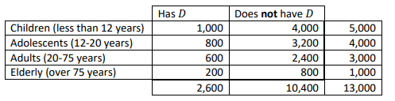

P(A) = 1000/12000

P(B) = 2600/13,000

P(A n B) = P(A) * P(B) == independent

----------------------------

Roll one die.  Let A be the event that the outcome on the die is an even number.  Let B be the event that the outcome on the die is 4 or smaller.

Are the events A and B independent?

Yes, because P(A|B)=P(A) and also P(A and B) = P(A)*P(B).

----------------------------

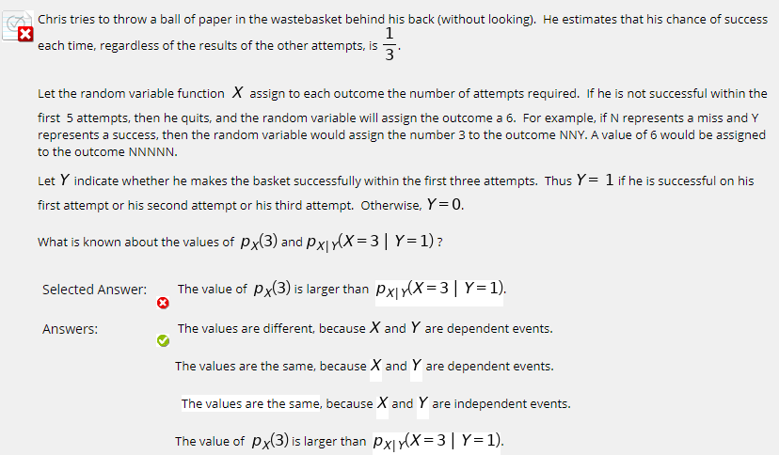

----------------------------

**Binomial Distribution Probability, Expected Value, and Variance**

On a multiple choice exam, a student guesses randomly and independently on each question. There are 20 questions on the exam and each question has 4 choices, only one of which is correct. Let the random variable function 𝑋 assign the number of correct answers on an exam completed in this manner.

What is the probability that the student gets at least 80% of the questions correct? Write down what device or software you used to assist with the computation. **nCr(20, 16)(.75)^(20-16)(.25)^16 + nCr(20, 17)(.75)^(20-17)(.25)^17 + nCr(20, 18)(.75)^(20-18)(.25)^18**

What is the expected value of the random variable 𝑋? E(X) = 20 (1/4) = 5

What is the variance of the random variable 𝑋? (20)(1/4)(3/4) = 3.75

----------------------------

Your sister is playing basketball.  She makes 4 tosses to a lowered basketball hoop, and whether the ball goes in each time is independent of the other trials.

Her chance of making the ball go in the hoop on a trial is 60%.

What is the probability that the ball goes in the hoop on exactly 3 of the 4 tosses?

0.3456

----------------------------

Approximately 8.33% of men are colorblind.  You survey men from a large population until you find one who is colorblind.  What is the expected value of the number of men you must survey until you find one that is colorblind?

This situation can be modeled with a negative binomial distribution with the number of successes equal to 1.  This is also the special case that is called a geometric distribution.

The expected value for a negative binomial distribution is given by the formula r/p where r is the number of successes needed and p is the probability of a success.

In this case, 1/0.0833 is approximately 12 men.

----------------------------

A cereal company puts a Star Wars toy watch in each of its boxes as a sales promotion.  Twenty percent of the cereal boxes contain a watch with Obi Wan Kenobi on it.  You are a huge Obi Wan fan, so you really want one of these watches.  If you buy 100 boxes of cereal, what is the expected value of the number of watches you find?

A binomial random variable is a good model for this problem if we assume there is such a large number of watches that buying one box doesn't change the probability of getting a watch in another box.

In that case, the probability of success is p= 0.20 and the number of trials is n=100.  So the expected value is 100*0.20=20

----------------------------

On a multiple-choice exam, a student decides to test his luck.  His exam has 20 questions, each of which has 5 answer choices.  The student decides to roll a die on each question and use the result on the die as his answer;  any time that he rolls a 6, he just discards that roll and tries again.  

Let X be the number of questions he gets right on the exam altogether.  What is the probability he gets 10 or more questions correct using this method?

This situation can be modeled with a binomial distribution with n= 20 and p= 1/5 =0.20

To find the probability of 10 or more questions correct.  Using a good calculator you can find the sum of the probability of 10, 11, 12, 13, 14, 15, 16, 17, 18, 19 or 20 correct.

That result is roughly 0.0026

----------------------------

Which of the following situations can be modeled with a binomial distribution?

A:

|  |
| --- |
| You guess on a 10 question multiple-choice test with 4 possible answers (only one of which is correct) for each question and count how many questions you get right. |
|  | Correct  You roll a six-sided die with animals on each side 20 times and count the number of times a duck appears on the top face. |
|  | Correct  A pond is filled with 100 yellow ducks. Ten yellow ducks have the word "Winner" written on the bottom of them.   You randomly pick up a duck and look at the bottom of it to see if it has the word "Winner" written on the bottom.   You then place the duck back into the pond.  You do this 14 times, drawing and replacing, and count how many times you see the word "Winner". |

**Compute Expected Value of Continuous Random Variable**

Tungsten

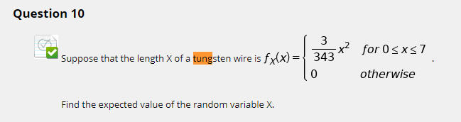

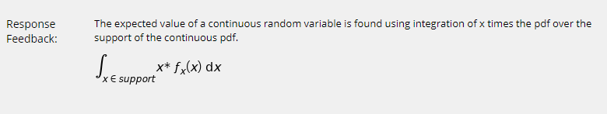

**Probability Using Uniform Continuous Random Variable**

Assume that a bird lands at a location that is Uniformly distributed along an electrical wire of length **200** feet.  The wire is stretched tightly between two poles.  What is the probability that the bird is 20 feet or less from one or the other of the poles?

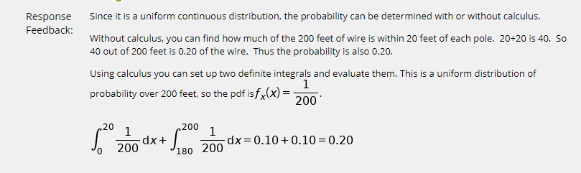

----------------------------

A wall in a room is 100 inches tall and 120 inches wide.  There is a painting on the wall that is 50 inches by 60 inches. If a tennis ball is accidentally flung at the wall, and the location where it lands is Uniformly distributed on the wall, what is the probability that the tennis ball hits the painting?

The painting covers 1/4 of the area of the wall.

**Normal Distribution**

Children's movies run an average of 98 minutes with a standard deviation of 10 minutes.  Assuming that the running time is normally distributed, what is the approximate probability that a randomly chosen children's movie has a running time between 88 and 108 minutes?

 Approximately 68% of the area under the normal distribution is within 1 standard deviation of the mean.  In this problem the mean is 98, so 1 standard deviation below the mean would be 88 minutes and 1 standard above the mean would be 108.  The area will serve as a proxy for the probability and gives the answer 68%.

----------------------------

Choose all of the answers below that would give you the correct answer to the question "If the weight of a beagle is normally distributed with a mean of 17.2 pounds and a variance of 3.2, what is the probability that a randomly chosen beagle weighs between 16 and 20 pounds?"

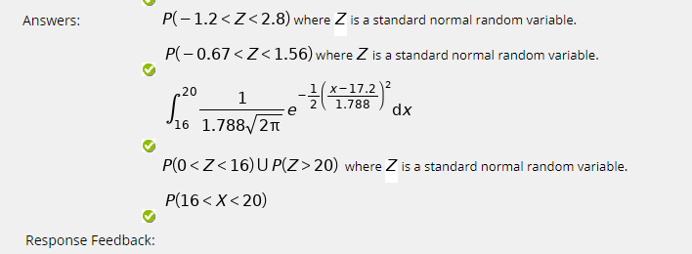

----------------------------

Assume that  has a normal distribution with a mean of 100 and a standard deviation of 15.  Find a value of B > 0 such that P( -b <= X <= b) = .95

X

This is equivalent to finding the area under the standard normal curve that gives an area of 0.95 and then shifting and scaling that value by the mean and standard deviation of   respectively. The value 1.96 is the number of standard deviations away from the mean you need to be in order to capture 95% of the area.  Notice that 1.96 is very nearly equal to 2, so sometimes we get lazy and use 2 as an approximation.

----------------------------

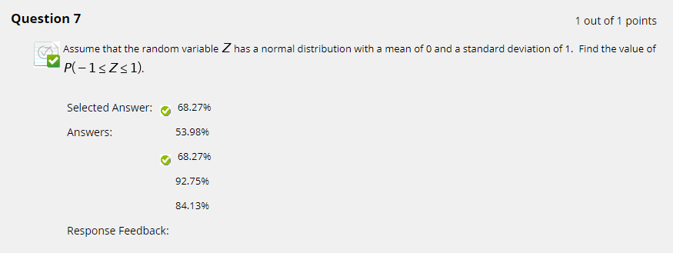

----------------------------

Children's movies run an average of 98 minutes with a standard deviation of 10 minutes.  Assuming that the running time is normally distributed, what is the approximate probability that a randomly chosen children's movie has a running time between 78 and 118 minutes?

Approximately 95% of the area under the normal distribution is within 2 standard deviations of the mean.  In this problem, the mean is 98, so 2 standard deviations below the mean would be 78 minutes and 2 standard deviations above the mean would be 118.  The area will serve as a proxy for the probability and gives the answer 95%.

----------------------------

